Benson Weibell Portal Page Site Plan:

Purpose:
Create a portfolio webpage that will display my created websites and projects. This website will allow for easy navigation to see what I have created.

Audience:
For employers and friends to who are curious as to what webpages I have created.

Logo:


Style Guide:
Color Palette:
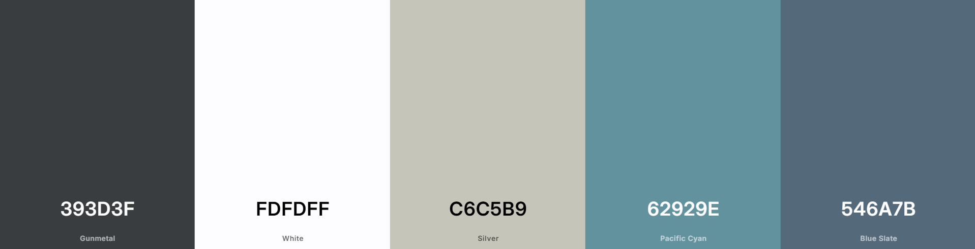

Hex Color Codes:
#393d3f
#fdfdff
#c6c5b9
#62929e
#546a7b

Typography:
Heading font: Josefin Sans
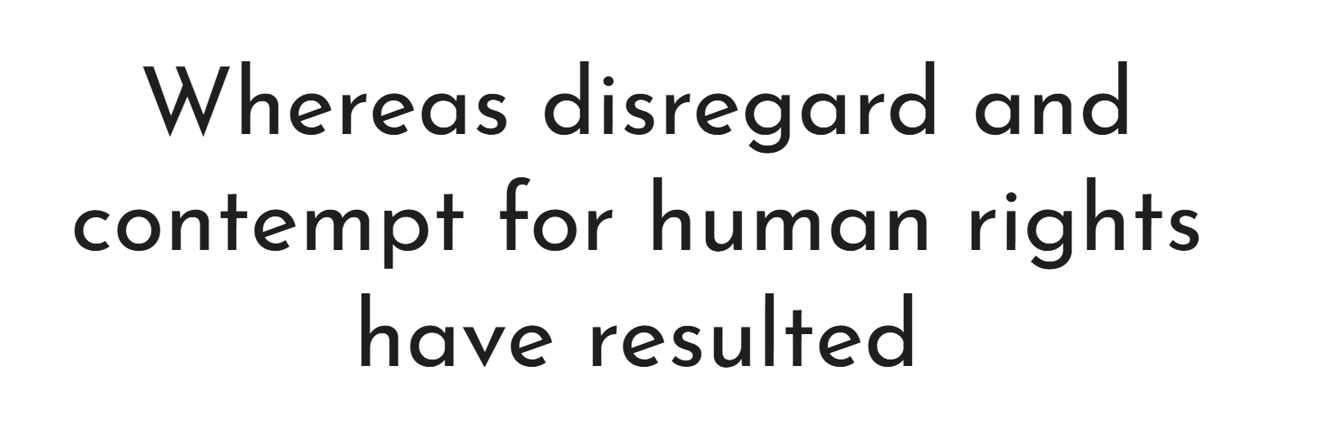
Paragraph font: Abel


@import url('https://fonts.googleapis.com/css2?family=Abel&family=Josefin+Sans:ital,wght@0,100..700;1,100..700&display=swap');

Wireframe:
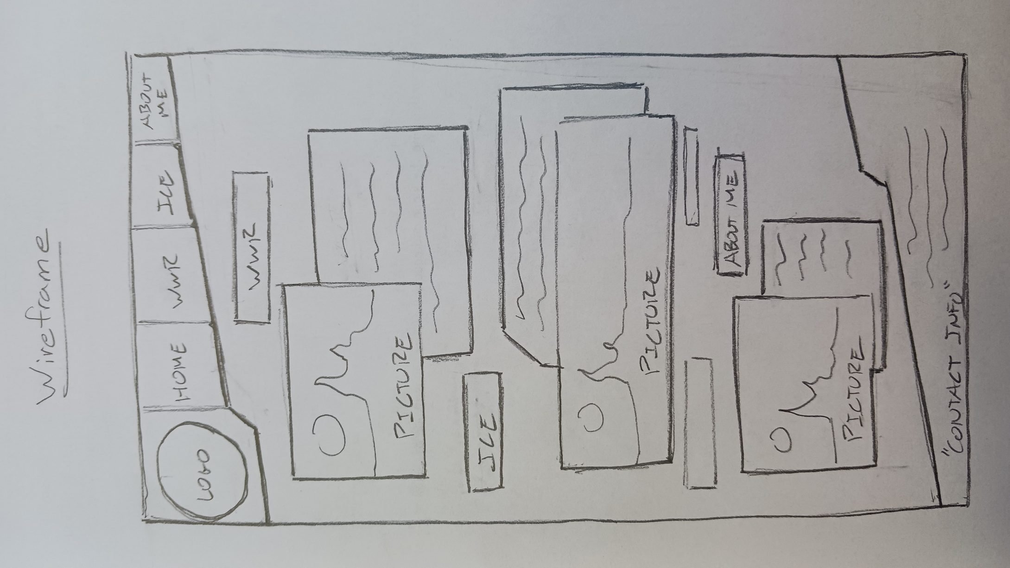
Site Map:


